EXERCISE 1.1

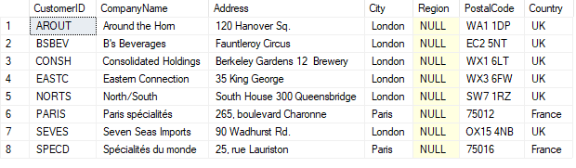

EXERCISE 1.2

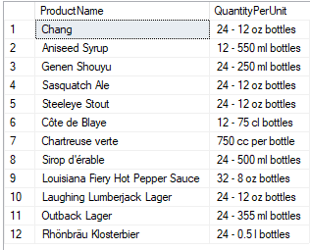

EXERCISE 1.3

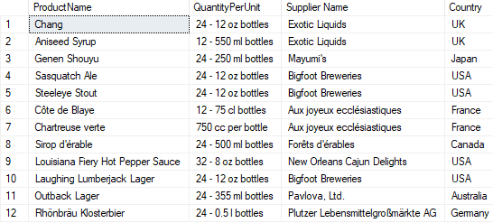

EXERCISE 1.4

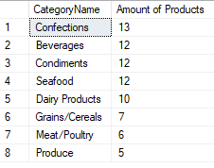

EXERCISE 1.5

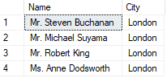

EXERCISE 1.6

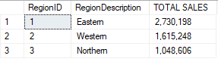

EXERCISE 1.7



EXERCISE 1.8



EXERCISE 2.1

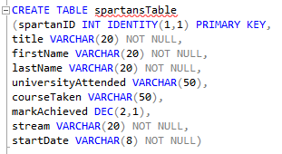

EXERCISE 2.2

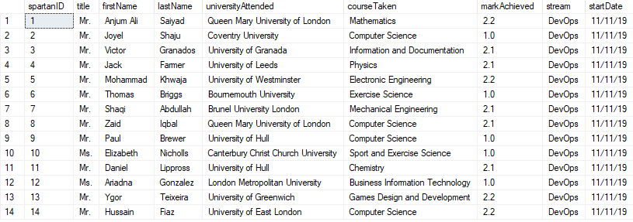

EXERCISE 3.1

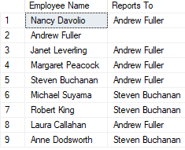

EXERCISE 3.2

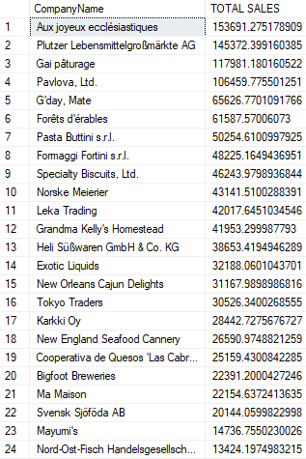



EXERCISE 3.3

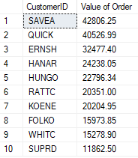

EXERCISE 3.4

